Eye regions localization

Introduction: the eye regions

Eyes are the most prominent features on the face. The eye detection problem has been studied extensively. Reliable biometric identification of people has been an important research area for a long time. Due to the current political situation and new legislation, it has become increasingly important for example in access and border control. Currently, most of the efforts are concentrated on iris detection.
The localization of the parts of the eye can also be used for the emotion recognition algorithms.
Computer vision techniques have been successfully utilized in fingerprint and iris recognition, and especially fingerprint-based systems are becoming ubiquitous. Even though iris is seen as the most reliable biometric measure, it is still not in everyday use because of the complexity of the systems.
One of the future challenges in the development of iris recognition systems is their incorporation into devices such as personal computers, mobile phones and embedded devices. In such applications, the computational complexity and noise tolerance of the recognition algorithm play an important role.
The canthus (eye corner) is more stable than iris, since the orientation and shape of canthus are not influenced by gaze direction or eye status. However, the accurate detection of canthus is somehow more difficult than iris detection. This is mainly because that the canthus located in skin region does not have unique grayscale characteristics like iris, and the presence of wrinkles or pouches around eyes will disturb the canthus appearances. Moreover, the canthus has a high-level, semantic definition. It is “the angle formed by the meeting of the upper and lower eyelids”. This definition makes the canthus more difficult to be fully characterized by edges, corners, or other low-level texture descriptors.

The basic algorithm

Now we show you our basic idea for detecting the eye regions.
First, we take some still color images with faces or one pair of eyes. We need some restrictions for good result, such us straight head and visible eyes.
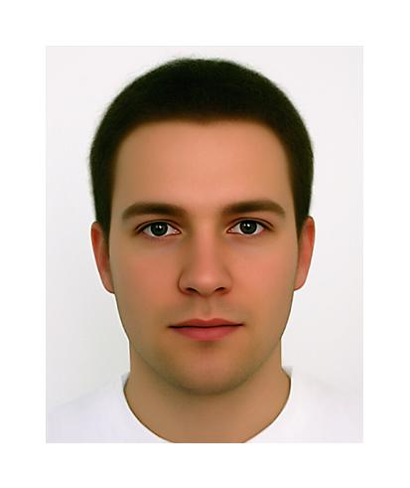
Original image

The first step of our algorithm is to apply a skin segmentation on the face image, using the transformation between color spaces, namely we convert the RGB picture into hsv color space and to the YCbCr color space. From this color space we only use the color information because the Cb and the Cr components give a very good idea of the probability for a pixel to be a part of skin or not. We obtain the Cb and Cr information using the next two formulas:

$\begin{aligned}\left\{\text{Cb}=0\text{.}\text{148}⋅R−0\text{.}\text{291}⋅G+0\text{.}\text{439}⋅B+\text{128}; | \right.\end{aligned}$

Then we apply some thresholds for Cb and for Cr components and also for the hue. If those three conditions are simultaneously satisfied then we say that the pixel in hand is a part of skin. Else we put the pixel to black.
The result of this operation is that all the skin pixel are put to white and all other pixels to black.

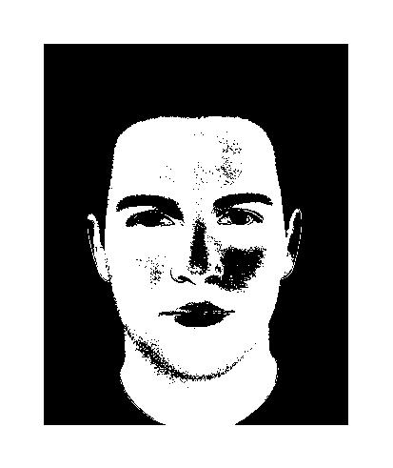
Possible skin pixels

After we have the segmented face we apply some morphological operations for filling the holes inside the detected skin region.
This morphological operations are namely, erosion with a disk shaped structural element with the dimension of the radius set at 3 pixels followed by a dilatation with a disk shaped structural element with the dimension of the radius set at 5 pixels.
Then we use a filling function build in Matlab for filling the remaining holes (imfill).

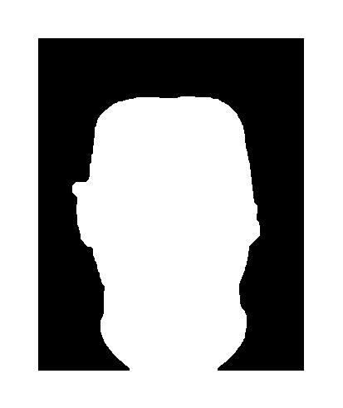
Face pixels

After doing this morphological operation we have to find the positions of the eyes. For finding the highest possible positions, we are using image registration techniques, based on template images (atlases). The templates were chosen as natural eyes, and we used two templates: one for the right and one for the left eye.

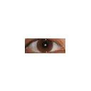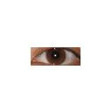
Eye templates (atlases)
We looking for the right and the left eye independently

Basically we are searching for two parameters: one for the size of the eye templates, and one for the correlation threshold: we implemented a correlation between a template and the original image for doing the eye tracking, but only in the white area resulted after the hole filling process. We are doing the correlation on grayscale level. The template was chosen as a natural eye, and we used two templates, for the two eyes.
We did the scaling of the eye so it could automatically fit in any images we apply it on, and also the correlation factor is calculated automatically for the same reason (the difference between the images). This parameters can be also manually set.
In case of full face images we first search on the upper half on the image in the following steps, using the multi-scale image representation: first we scale down the image for the search to be faster, and when a parameter fitting our conditions is found, we search in it’s neighborhood on the non-scale upper half of the image for another matching parameters. It is good to be mentioned that we are searching for two points that have almost the same Y coordinate value considering the image representation as a matrix.
The parameter search is based on guided brute-force search: thanks to the restrictions its runtime is quite acceptable. In the case of lower restrictions (e.g. tilted head) there are far more parameters, so we should use genetic algorithm, simulated annealing or other evolutional techniques.

correlation
Optimal solution
size
Search route for finding the optimal parameters for eye registration

We decide that a founded parameter pair is optimal if the matches on the correlation image have the following properties (eye_eps is a parameter in our algorithm):

- Number of the matches is two, and |y₁-y₂| < eye_eps (the Y coordinates are almost the same)
- Number of the matches is three, and one of them (e.g. y₂) has highly different Y coordinates than the other 2, and |y₁-y₂| < eye_eps

So if one of the parameters is incorrect, we find have too few or too many matches. Despite of the number of the matches, we can force the search path closer to the optimal solution.

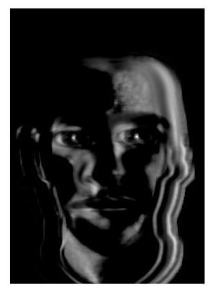
The template correlations

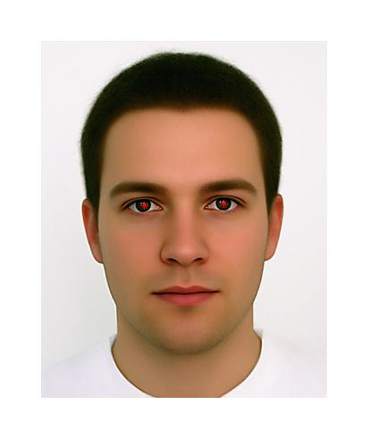
Detected eyes base on the correlation image

For the corners detection we used the template corners coordinates and then we scaled them along with the template when doing the eye matching.

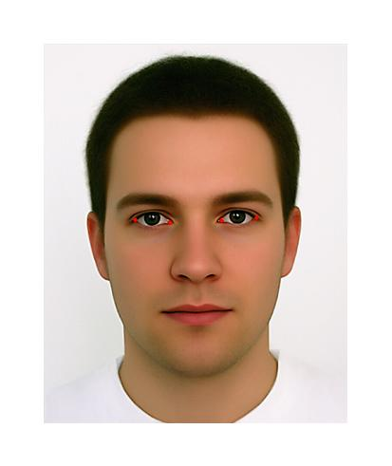
Detected corners base on template corners

For the next step we looked for the center of the pupil and for the iris.
First we cut out funded eyes as the Region of Interest (ROI) and then we transform it from the RGB to HSV color space.
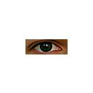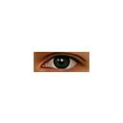
The ROIs

Doing segmentation by threshold the hue, and all the parts that should be the pupil will be white and the rest will be black. Because this segmentation is not perfect next we apply some morphological operation to make only one white spot on the segmented image.


The thresholded pupil / iris

We then compute the center of the white area or white areas (if still more than one is there despite the morphological operation) so we have the center of the pupil. After this, we calculate the fit sized circle from the center of the pupil until we find lighter pixels that surely are not a part of the iris and we stop, therefore detecting the iris with this circle.
In the end, we put red dots on the center of the pupil and on the corners, and a red circle to show the iris boundary.

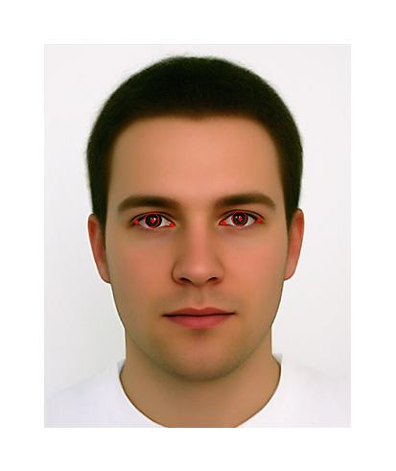
The final image showing the corners, the irises and the center of the pupils

Advantages and disadvantages

Our algorithm has numerous advantages and disadvantages:

Good news:

- Using atlas registration it is much easier to find the corners, which is generally the hardest to find
- In case of good image registration the speed and result for detecting the eye regions is good
- Easy to implement the algorithm
- Easy to improve the algorithm with several ideas

Problems:

- Because of the small parameter space in some cases we can’t register the eyes. More parameters means exponentially more time to find the parameters
- Not work with images that eyes’ does not look like the atlases – the registration failing
- Strong restrictions for the input images
- Take some seconds to detect the regions (registration) – not real-time, but with a better implementation it could be

Some ideas for possible improvements

We can reach better results (or runtime) with several additional implementations. Some ideas:

- Use database of atlases to find better match
- Allow other parameters during the registration search, e.g. rotation, non-uniform scaling or more affine transformations. In this case you need better search algorithms, such as simulated annealing or evolutional algorithms
- For the eye corners detection it can increase the accuracy if we use some corner detection algorithms, such as Harris corner detector. Then we choose the closest detected corners to our originally founded corners. We also can use such information that the eye corners has lighter neighbor pixels inside the eye, and darker (skin colored) neighbor pixel outside the eye
- For searching the pupil and iris we can use better threshold algorithms, fuzzy segmentation, atlas based image registration, etc.
- Instead of circle we can try to draw ellipse, or other better iris-contour like shapes. We can also use e.g. active contours
- Using more efficient code language and better implementations

